American Cultural Studies. By Neil Campbell and Alasdair Kean

Second Edition 2012
Table of Book Contents:
http://www.amazon.com/American-Cultural-Studies-Introduction-Culture/dp/0415598710/ref=dp_ob_title_bk#reader_0415598710
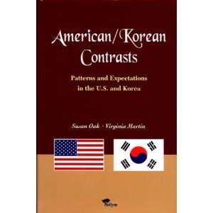

by Susan Oak & Virginia Martin size: 21.7x14cm 296pages. publisher: Hollym.
About this book
What are the differences and similarities between U.S. and Korean Culture?
There are many books for Americans on understanding Korea or for Koreans trying to understand the U.S., but this is the first book to attempt to reach both audiences. Authors highlight in this book how average Americans and Koreans generally behave and what they expect in similar circumstances -- American ways and Korean ways.
This book was designed for anyone who interacts with Americans or Koreans and wishes to know more about the differences and similarities between American and Korean culture and society. It has been written in a simple and direct style, with emphasis on the more practical aspects of human social interactions and customs. This book not only describes what Americans and Koreans generally do, it also describes why they behave as they do. In this respect, the book could also be subtitled "Understanding Two Distinct Cultures".

